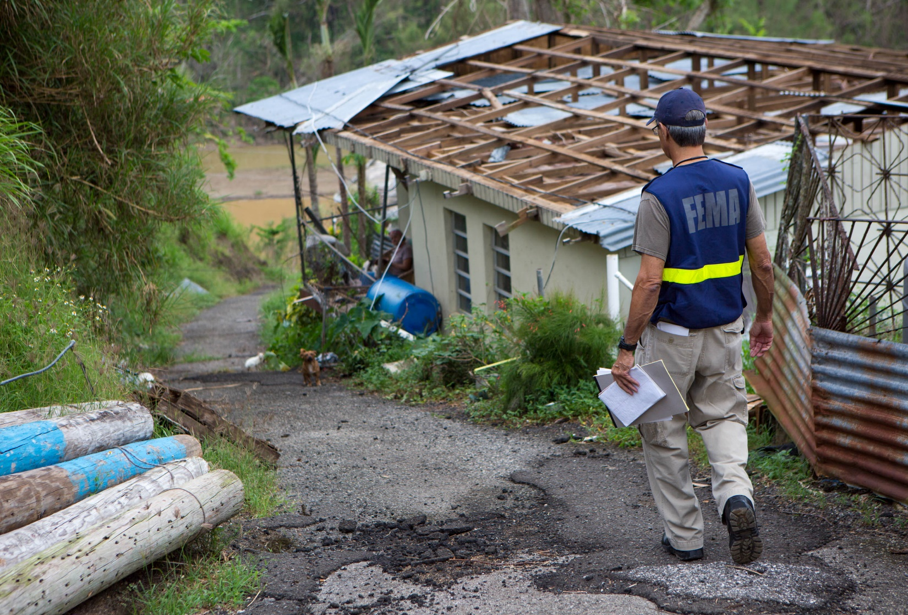
Standard Operating Procedure
Enter Title
January 2026


This page intentionally left blank

Table of Contents
SOP – Enter Title 2
1. Purpose 2
2. Scope and Applicability 2
3. Supersession 2
4. Roles and Responsibilities: 2
5. Required Materials and Tools: 2
6. Enter Title (Step-by-Step Instructions) 3
6.1. Enter Subtitle 1 3
6.2. Enter Subtitle 2 3
6.3. Enter Subtitle 3 4
7. Safety and Compliance Guidelines: 5
8. Revision History: 5
Appendix A. ACRONYM LIST 6
Appendix B. GLOSSARY 8
Appendix C. AUTHORITIES AND FOUNDATIONAL DOCUMENTS 10

SOP – Enter Title
  - Purpose
Enter Purpose
  - Scope and Applicability
Enter Scope and applicability
  - Supersession
This document does not supersede any existing FEMA doctrine.
  - Roles and Responsibilities:
Role | Responsibility
Example: Department Manager | Ensures the process is followed and reviews outcomes.
Example: Staff Member | Executes assigned tasks in accordance with the SOP.
Example: Quality Officer | Monitors compliance and updates SOP as needed.
(Add or modify roles as appropriate for each department.)
  - Required Materials and Tools:
(List all necessary materials, equipment, software, or resources required to complete the procedure.)

  - Enter Title (Step-by-Step Instructions)
    - Enter Subtitle 1
- Step 1
- Step 2
  - Sub step 1
  - Sub step 2
  - Sub step 3
    - Sub-sub step 1
    - Sub-sub step 2
    - Sub-sub step 3

    - Enter Subtitle 2
- Step 1
- Step 2
- Step 3
- .
- .
- .

    - Enter Subtitle 3
- Step 1
- Step 2
- Step 3
- .
- .

  - Safety and Compliance Guidelines:
- Follow all FEMA and DHS travel safety standards.
- Ensure all travel arrangements comply with federal travel regulations and FEMA policy.
- Protect Personally Identifiable Information (PII) in accordance with FEMA’s data protection policies.
- Report any deviations, errors, or incidents immediately to the FIWA Travel Team Lead.
  - Revision History:
Version | Date | Description of Changes | Author | Approved By
1.0 | MM/DD/YYYY | Initial SOP Template | [Your Name] | [Department Head]

Appendix A. ACRONYM LIST
Acronym | Definition
CDP | Center for Domestic Preparedness
CDM | Curriculum Delivery Module
CEP | Curriculum Evaluation Program
CORE | Cadre On-Call Response/Recovery Employee
CTAS | CDP Training Administration System
DHS | Department of Homeland Security
DFTO | Disaster Field Training Operations
EMU | Emergency Management University
FEKC | FEMA Employee Knowledge Center
FEMA | Federal Emergency Management Agency
FIWA | FEMA Incident Workforce Academy
FOD | Field Operations Directorate
FQS | FEMA Qualification System
HQ | Headquarters
ILT | Instructor-Led Training
IMDA | Instructor Materials Download Application
IQC | Instructor Qualification Course
IQPG | Instructor Qualification Program Guide
LER | Labor and Employee Relations
OCHCO | Office of Chief Component Human Capital Officer
OPPA | Office of Policy and Program Analysis
ORR | Office of Response and Recovery
POC | Point of Contact
POI | Plan of Instruction
PTB | Position Task Book
ROE | Return on Expectation
ROI | Return on Investment
SLTT | State, Local, Tribal, and Territorial
SME | Subject Matter Expert
SOP | Standard Operating Procedures
TtT | Train the Trainer
WDD | Workforce Development Division

Appendix B. GLOSSARY
Cadres: Responsible for identifying and coordinating the FQS training needs of cadre members and potential Incident Workforce Instructors within their cadre.
Class: The singular occurrence of a course which is sometimes referred to as a delivery.
Close-Out Procedures: Actions taken at the conclusion of an FQS class to archive supporting documentation, record satisfactory completion, and notify personnel responsible for awarding Course Credit.
Controlled Materials: Instructional materials that may be used during a course but cannot be freely reproduced or shared outside of that learning environment. This can mean proprietary content, sensitive information, assessment materials, or regulated information.
Course: A set of curricula or course content that has been approved by the FQS Branch for FQS Incident Workforce training.
FEMA Incident Workforce Academy (FIWA): Responsible for promoting the development of an expeditionary workforce through the coordination and execution of delivery of incident workforce training.
FEMA Qualification System (FQS) Training Proponent: Responsible for the oversight of an FQS course. The FQS Training Proponent is typically cadre management, the FIWA Training Section, or other office located within the Field Operations Directorate (FOD). The FQS Training Proponent responsibilities for FQS course management are normally assigned to a Cadre Training Manager, FIWA Course Manager, or Course Coordinator for routine oversight.
Field Operations Directorate (FOD): Ensures the operational readiness of FEMA’s incident workforce and coordinates the federal interagency response and recovery to achieve timely, effective, and integrated field operations that support the whole community across all mission areas. The training and qualification of FEMA’s incident workforce is crucial to achieve operational readiness in accomplishing the Agency’s mission requirements.
Field Training Deliveries: FQS classes that occur at Joint Field Offices, Initial Operating Facilities, Joint Recovery Offices, State, Local, Tribal, Territorial (SLTT) facilities, or other field-based incident locations.
FIWA FQS Training Point of Contact (POC): FIWA staff member who works with Cadre Training Manager on requested courses and the assigning of instructors, among other issues. This person relies on the greater Operations Coordination Section for support as necessary. Course coordination POCs manage the daily operations of a FQS course including the following:
- Process participant enrollment and issue participant credit
- Provide guidance to instructors in the form of updates and in-service training, and providing prompt response to inquiries or concerns related to their assigned FQS course
- Communicate to and coordinate with instructors, support staff, participants, and FEMA leadership, cadre management, FIWA, Regional staff, and FQS Branch; and
- Ensure that classes are consistently scheduled and delivered in compliance with FQS guidelines and FEMA values.
Objective Assessment: A tool used by an instructor for measuring participant knowledge, skills, and/or attitudes. Sometimes referred to as a Kirkpatrick Level 2 evaluation. The Objective Assessment will be used at the beginning of a class as a Formative Assessment and at the end of a course as a Summative Assessment
Subject Matter Experts (SMEs): Responsible for supporting Incident Workforce Instructors in the delivery and validation of course content.
Train the Trainer (TtT): Serve as procedure to validate instructor readiness by assuring their understanding of the instructional content, theories, practical exercises, and classroom delivery strategies. The Train-the-Trainer (TtT) concept allows for a qualified FEMA instructor to train an instructor on specific content outside the purview of the instructor qualification course and its associated requirements. TtTs assist instructors with expedited course instruction preparation and delivery. Not all FQS courses require a formalized TtT program. Please refer to the FEMA Incident Workforce Instructor Qualification Program Guide for latest information regarding TtT processes.
Training Development Section: Field Operations Directorate (FOD) Workforce Development Division (WDD) Training Development Section is responsible for course content, course modifications, and Incident Workforce Instructor evaluations.
Training Point of Contact (POC): Typically, a Training Manager assigned to a field location who provides direct support to FQS training deliveries.
Virtual (Online) Trainings: Interactive e-learning courses that work on most smart devices. Virtual trainings allow for interactivity between participants and instructors. Some examples include Zoom trainings, Adobe Connect, Microsoft Teams, and others.
Workforce Development Division (WDD): Responsible for developing, coordinating, resourcing, and executing training, education, experiential learning, and standard qualification processes to ensure the incident workforce is well prepared to support disaster survivors and first responders in all-hazards incidents. Additionally, WDD administers the FQS, manages course delivery, and development requirements for the incident workforce in coordination with the cadres, and leads initiatives related to expeditionary workforce efforts.

Appendix C. AUTHORITIES AND FOUNDATIONAL DOCUMENTS
- Homeland Security Presidential Directive (HSPD) 5, Management of Domestic Incidents, February 2003.
- Post-Katrina Emergency Management Reform Act (PKEMRA), Pub. L. No. 109-295, 2006.
- Code of Federal Regulations (CFR), Title 44, Emergency Management and Assistance.
- Presidential Policy Directive (PPD) 8: National Preparedness, March 2011.
- Robert T. Stafford Disaster Relief and Emergency Assistance Act, Pub. L. No. 93-288, as amended, 42 U.S.C., Sections 5121–5207, April 2013.
- Department of Homeland Security (DHS), National Incident Management System (NIMS), Third Edition, October 2017.
- DHS Directive 256-1, Anti-Harassment, May 2019.
- FEMA Directive 010-5: Incident Workforce Training, August 2019.
- FEMA Directive 010-6: FEMA Reservist Program, Version 2, January 2017.
- FEMA Directive 010-8, FEMA Incident Workforce Deployment, October 2014.
- FEMA Directive 010-9, Incident Workforce Cadre Management, June 2014.
- FEMA Directive 123-18, Standard FEMA-Distinctive Clothing, July 2011.
- FEMA Directive 256-5, Anti-Harassment and Retaliation, September 2015.
- FEMA, Manual 252-11-1, Cadre of On-Call Response/Recovery Employee (CORE) Program, August 2015.
- FEMA Manual 141-1-1, Records Management Files Maintenance and Records Disposition, March 2014.
- FEMA Manual 123-10-1, Absence and Leave, December 2015.
- FEMA, Incident Management and Support Keystone, January 2011.
- FEMA, Incident Management Handbook, November 2017.
- FEMA, Incident Management Manual, September 2015.
- FEMA, Regional Incident Support Manual, January 2013.
- FEMA, National Disaster Recovery Framework, Third Edition, December 2024.
- FEMA, National Response Framework, Fourth Edition, October 2019.
- FEMA, Publication 1, March 2025.
- FEMA, Cadre Management Guide, October 2014.
- FEMA, Personnel Mobilization Guide, January 2017.
- FEMA, FEMA Qualification Guide, August 2019.
- FEMA, 2018-2022 Strategic Plan, March 2018.
- FEMA Incident Workforce Instructor Qualification Program Guide, June 2019.
- National Emergency Training Center (NETC) Instruction 1100.1, Conduct on the NETC Campus.
- FQS Curriculum Development Standard Operating Procedures, July 2020.

